[Insert #^{th/st/nd/rd}] Anniversary
Battle of Midway
Welcome to the Celebration
[Weekday, Month DD, YYYY] ★ [Locale] ★ [Address or Location]

The Spirit of Midway
During the Battle of Midway, at 2:14 pm on June 4, 1942, on board carrier Yorktown, a Japanese bomb scores a devastating hit. In the number one fire room, 37-year-old Chief Water Tender (Acting) Charles Kleinsmith, appointed to that rate only three days before, remains at the only undamaged boiler. Despite the red-hot boiler casing, the noxious fumes from ruptured uptakes, and imminence of an explosion, Kleinsmith supervises his six-man crew in keeping that boiler under steam with two burners still going, maintaining the ship’s vital auxiliary power as Yorktown Sailors repair the damage to the uptakes for boilers four through six. His courageous and efficient performance ultimately enables the carrier to go from dead in the water at 2:40 pm, to 20 knots (the speed necessary to launch fighters) at 4:27 pm. Kleinsmith, by his professionalism and tenacity, exemplifies the Spirit of Midway.

The Road to Midway
Dawn Over Pearl Harbor
On December 7, 1941, the Imperial Japanese Navy carries out a devastating surprise attack on the U.S. Pacific Fleet at Pearl Harbor and on nearby military and naval installations on Oahu with carrier-borne planes. While the Japanese succeed in crippling the battle line,
the vital carriers are not present and thus form the basis of powerful and mobile striking forces to take the war to the Japanese.
Flying the High Pass to Victory
On March 10, 1942, following a succession of raids on Japanese island bases in the Pacific, 104 planes from the carriers Lexington and Yorktown fly through the one open pass available in New Guinea’s Owen Stanley Mountains to attack a Japanese invasion force off the ports of Lae and Salamaua. Only one aircraft is lost to enemy fire, and Navy planes sink three Japanese ships and damage ten. President Roosevelt calls the raid “the best day’s work we’ve had.”
Touching Tokyo
On April 18, 1942, Hornet, with Enterprise riding shotgun, launches 16 B-25 bombers 650 miles from Japan. These planes attack targets in Tokyo, Yokosuka, Yokohama, Kobe, and Nagoya. An attack on their home soil, previously unimaginable, convinces the Japanese Naval General Staff that they must attack the forward U.S. base on Midway Island to draw the troublesome U.S. carriers into decisive battle. One often ignored aspect of the action that day is the decimation of the picket line of Japanese patrol craft in the vicinity at the hands of carrier planes from Enterprise.
The Ships Never Fired a Shot
From May 4–8, 1942, at the Battle of the Coral Sea, aircraft from Task Force 17 trade attacks with Japanese forces. The surface ships in both forces never see each other; all attacks are by air. In the end, U.S. naval forces blunt the Japanese advance toward Port Moresby and sink one Japanese carrier, damage a second, and decimate the air group of a third, eliminating three carriers planned for use in the impending attack on Midway. The Japanese believe that they sink Yorktown in this battle, adding significant shock to the surprise attack she launches with Enterprise and Hornet in what would become known as
the Battle of Midway.

A Glorious Page in Our History
Throughout the Pacific Ocean, the U.S. Navy and the Imperial Japanese Navy each find the other’s aircraft carriers elusive targets. The Japanese strike Oahu on December 7, 1941, and conduct succeeding operations that culminate in a rampage across the Indian Ocean. The American carriers conduct a succession of raids from the Marshalls and Gilberts to Lae and Salamaua, culminating in the Halsey-Doolittle Raid on Japan itself. The U.S. raids foster a growing Japanese irritation with the ability of the U.S. carriers to strike unopposed. When the Japanese carriers finally engage the elusive Americans in the Battle of the Coral Sea—the first naval engagement where neither side sights the other, except by aircraft—the Americans triumph.
To eliminate the U.S. Navy’s carriers, the Japanese target Midway, an atoll that the enemy deems the “Sentry for Pearl Harbor.” Unknown to the enemy, however, U.S. Navy code-breakers’ efforts have identified Midway as the object of enemy intentions. Admiral Chester W. Nimitz, the Commander in Chief of the U.S. Pacific Fleet, knowing Midway’s centrality in the enemy’s strategy, reinforces it while dispatching forces to the Aleutians, the other objective in the Japanese strategy.
The complex Japanese operations involve a veritable armada, but its elements are scattered over a very wide expanse of ocean, making mutual support nearly impossible.
By contrast, Nimitz concentrates his forces. With Midway serving as essentially a fourth carrier, Nimitz sends a striking force formed around three carriers under Rear Admiral
Frank Jack Fletcher to a position north of Midway. U.S. search planes confirm the Japanese approach on June 3, 1942, but initial attacks on elements of the enemy
achieve little.
On the morning of June 4, 1942, planes from four Japanese carriers—all of whom were among the ones that had attacked Oahu six months before—pound Midway. Heroic Marine Corps fighter pilots, some of whom have only recently earned their wings, together with the intense antiaircraft fire, limit the enemy’s success. Brave but piecemeal attacks by Midway-based planes throw off the tempo of the Japanese carrier operations.
Still later that same morning, torpedo attacks by planes from the undiscovered U.S. carriers are repelled with heavy losses. The providential arrival of the Yorktown Air Group and Enterprise dive bombers, however, changes the course of battle in five minutes, as U.S. bombs turn three Japanese carriers into floating infernos. Two strikes from the Japanese carrier that survives the initial onslaught damage Yorktown and force her abandonment, but planes from Enterprise disable that fourth enemy carrier before the afternoon is out.
Action over the next two days claims a Japanese heavy cruiser, while a Japanese submarine sinks a destroyer and further damages Yorktown, which sinks on June 7. The loss of four Japanese carriers prompts the defeated enemy to retire.
Midway is never again seriously threatened. Admiral Nimitz’s informed willingness to take a calculated risk changes the complexion of the conflict in the Pacific. Courage, honor, and commitment abound at Midway, as those involved write, in Nimitz’s words, “a glorious page in our history.”

Marines at Midway
Navy PBY aircraft report sightings of the Imperial Japanese Navy at around 5:30 on the morning of June 4, 1942. The report: “Many planes, heading Midway.” Vice Admiral Chuichi Nagumo’s First Carrier Striking Force, four aircraft carriers, steams 150 miles northwest of Midway atoll.
At dawn, with sightings confirmed, the pilots and ground crews of MAG-22
launch fighters from VMF-221, followed by the VT-8 detachment of new Grumman
TBF Avengers, torpedo-equipped USAAF B-26s, and VMSB-241 scout bombers. Three divisions of fighters, seven F2A-3s and five F4F-3s, move to intercept the Japanese aircraft. Another 12 F2A-3s and a lone F4F-3 are held in reserve west of the island.
At 6:16 that morning, 30 miles from Midway, Marine fighter pilots spot a Japanese formation of Nakajima Type 97 carrier attack planes, operating in the high-level bomber role. The two groups of Marine aircraft attack, 25 Marine fighters taking on 107 enemy aircraft in defense of the tiny atoll. Only 10 return to Midway. Just two of those are fit to
fly again.
On the island below this air melee, the Sixth Defense Battalion stands ready to
defend Midway. At 6:30, the Commanding Officer gives orders to “fire when targets are
in range.” The radar station operators can see the enemy aircraft by then and report their distance. By 6:31 the guns on Midway atoll are fully engaged with enemy aircraft.
The Japanese bombers, guarded by Zero escorts, bomb the atoll’s seaplane hangar and ramps, fuel storage, and barracks. Others strike the runway, mess halls, and galley. Even the power station is hit. In between bomb explosions, the Zeros strafe gun pits, oil tanks, and anything that moves.
The first attack is over by 6:48 in the morning. The Japanese return to their carriers and, while the attack achieved heavy damage, Vice Admiral Nagumo’s strike received significant damage in the form of key strike leaders splashed by VMF-221. Fighters and
the Marine antiaircraft batteries destroyed at least five enemy planes, and another three ditched on the return flight to the carriers.

But VMSB-241, with 16 SBD-2s and 11 SB2U-3s, ordered to attack the Japanese carriers, do so with gusto. They lose 11 planes to antiaircraft fire and enemy fighters but score no hits in attacks on one carrier and a battleship.
At 6:30 on the morning of June 5, the Marines launch 12 bombers against two large enemy warships, the heavy cruisers Mikuma and Mogami. During the attack, Captain Richard E. Fleming, a participant in all the Marine actions at the Battle of Midway, attacks Mikuma. Although his bomber is hit by antiaircraft fire and bursts into flames, he stays in his dive and releases at 500 feet, receiving credit for a “near miss on the stern of the ship.” Unable to pull out, his plane crashes close aboard. He was awarded the Medal of Honor posthumously for his gallantry during June 4–5.
Robert J. Cressman, Naval History and Heritage Command

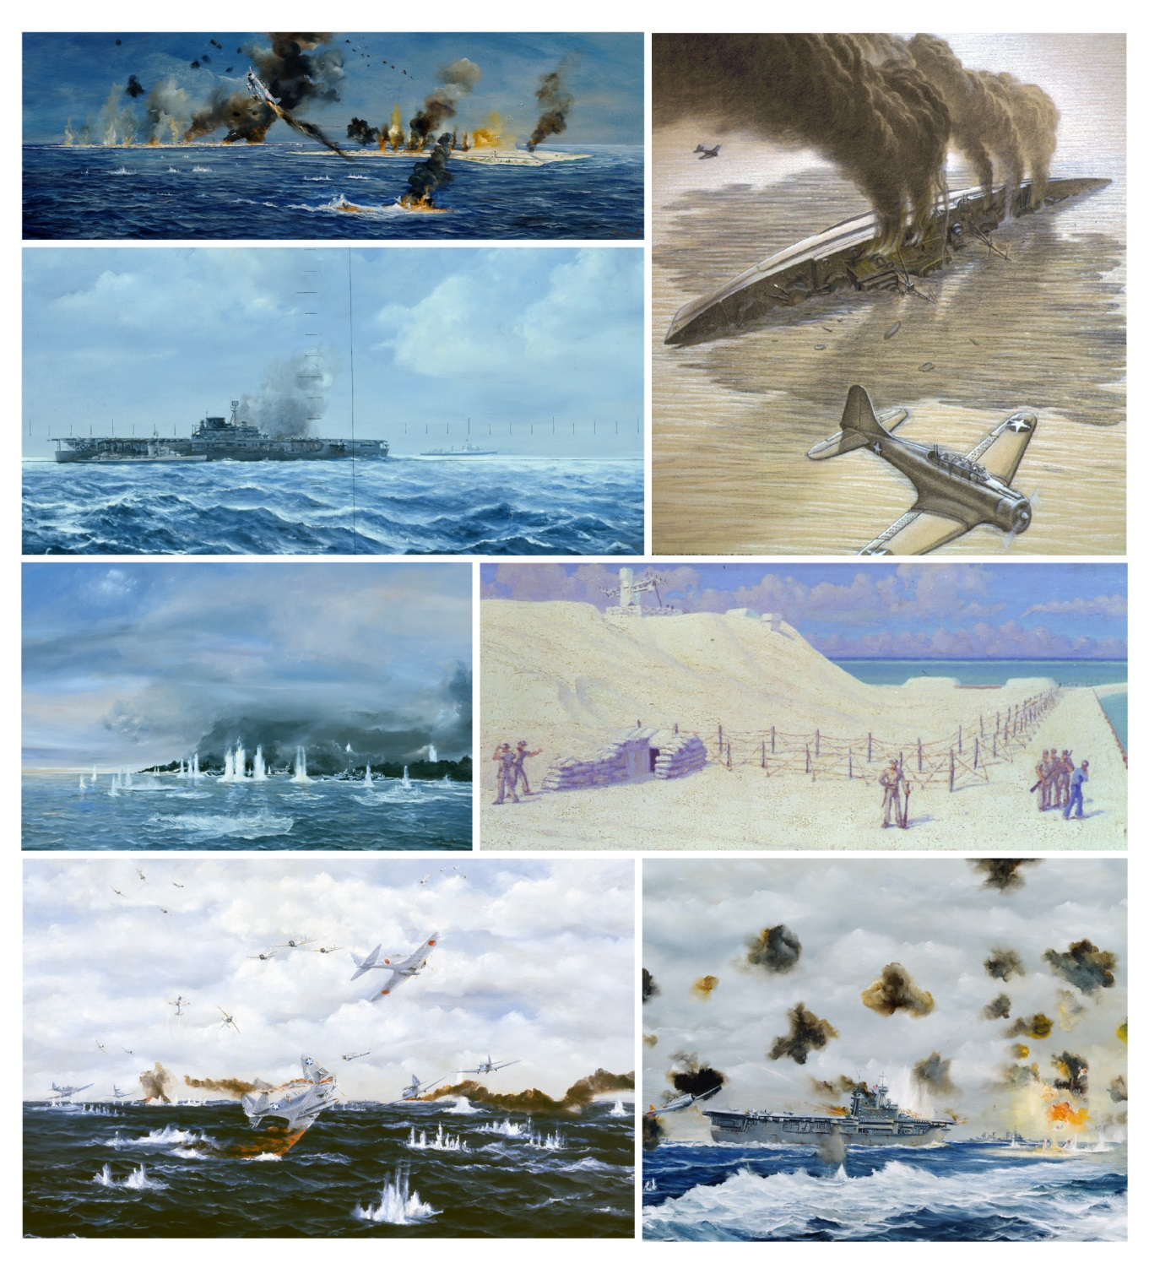
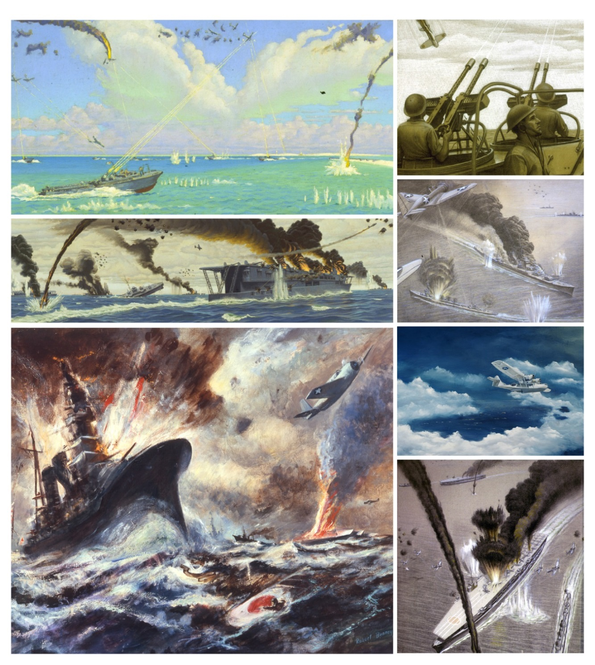

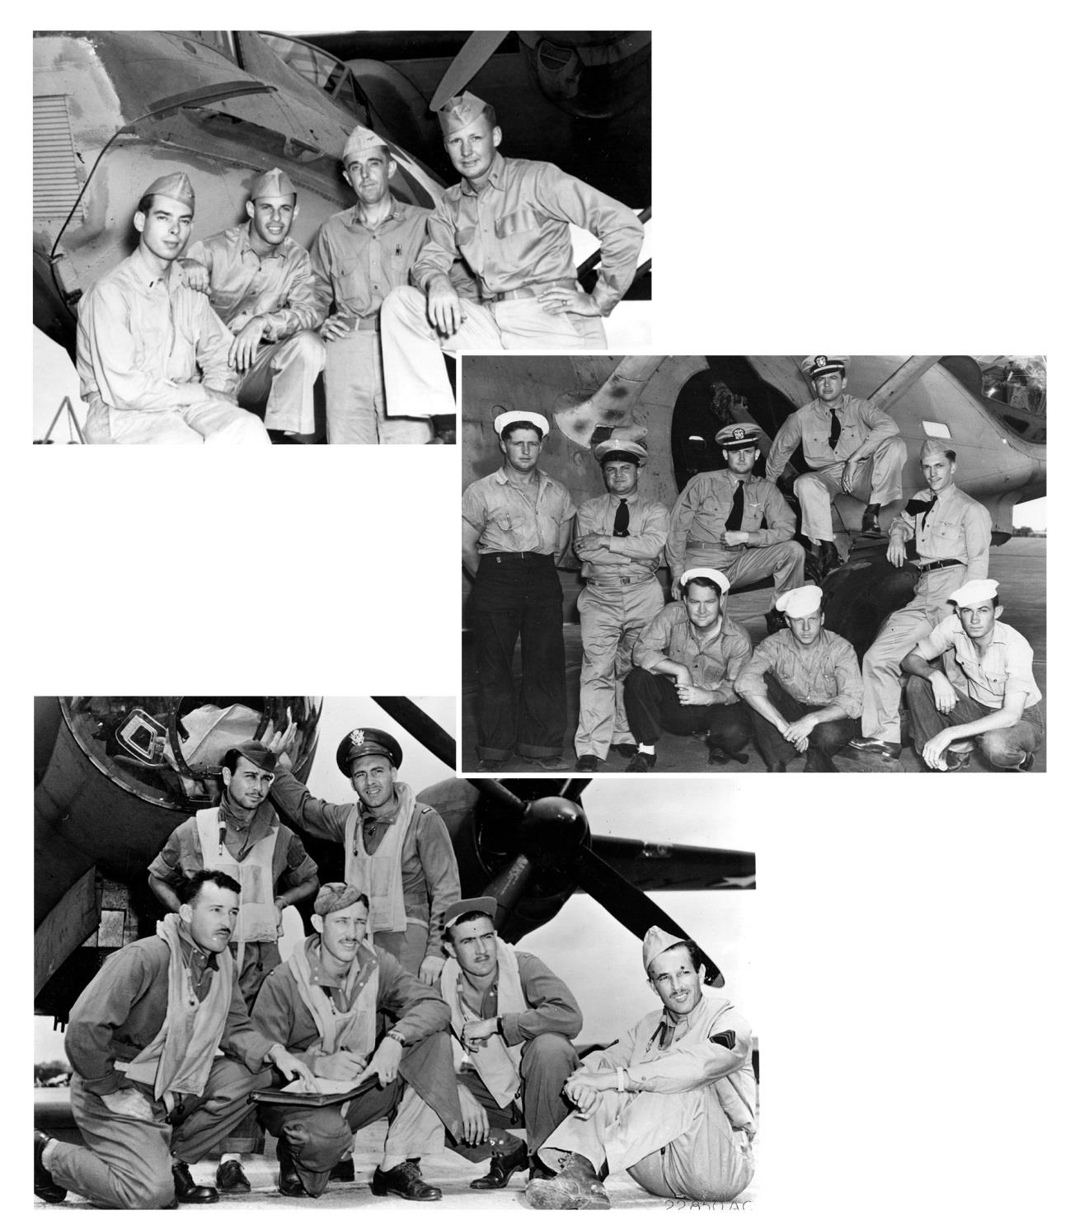
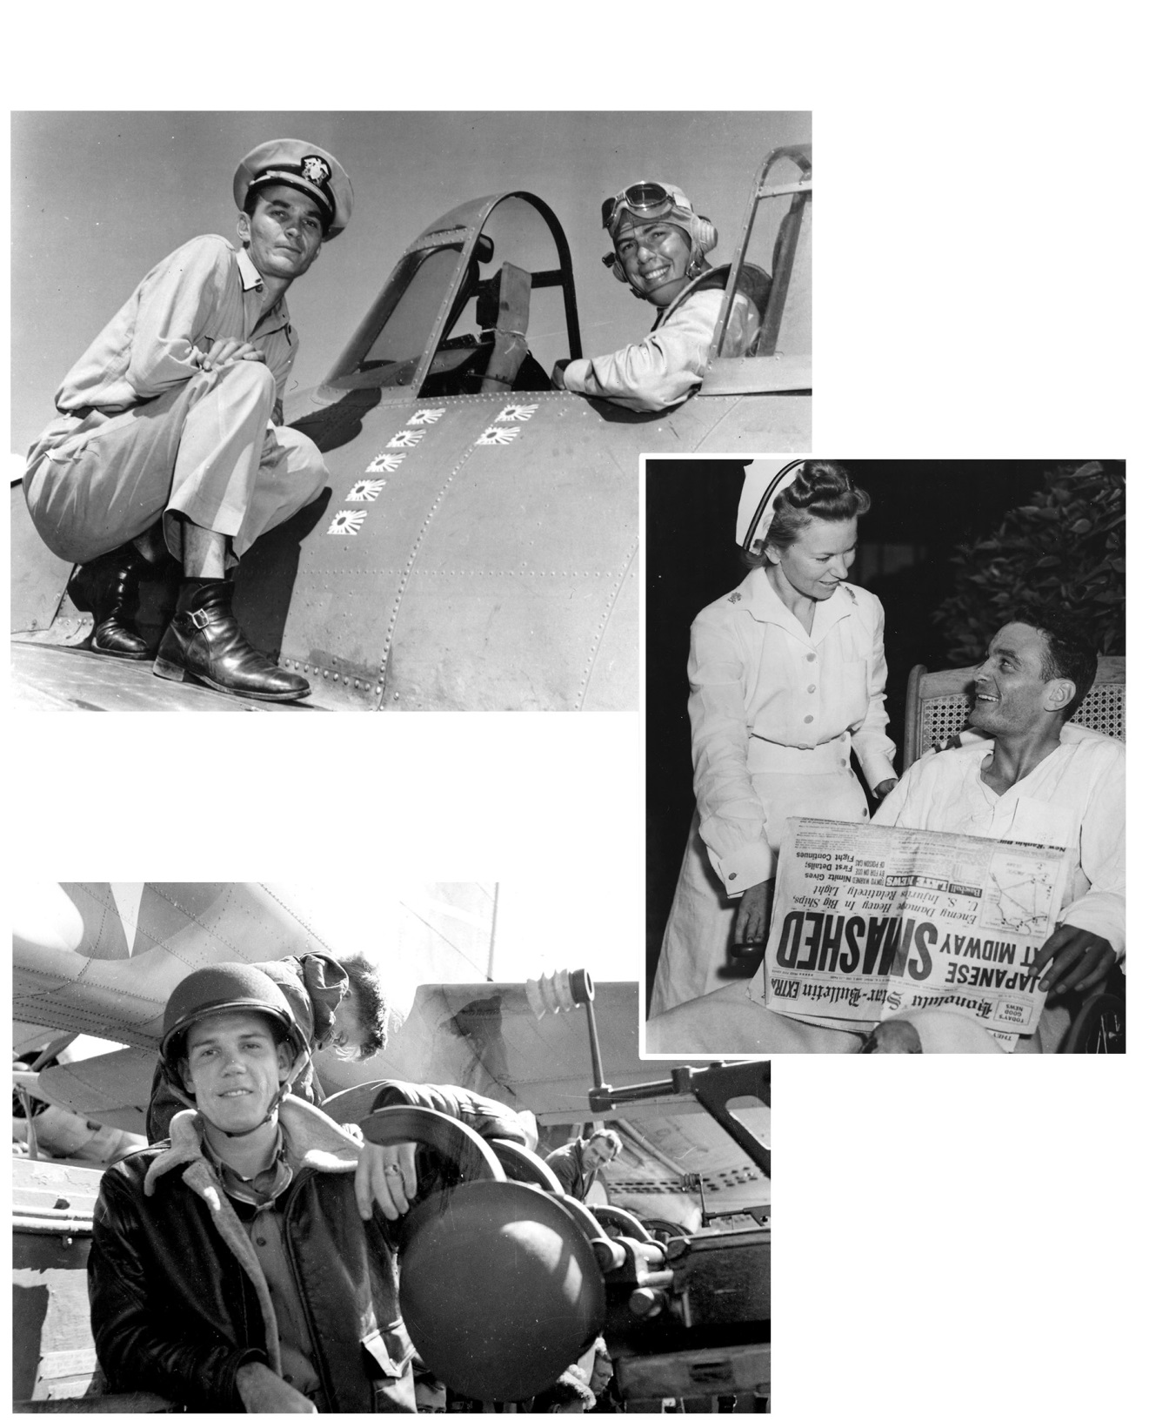

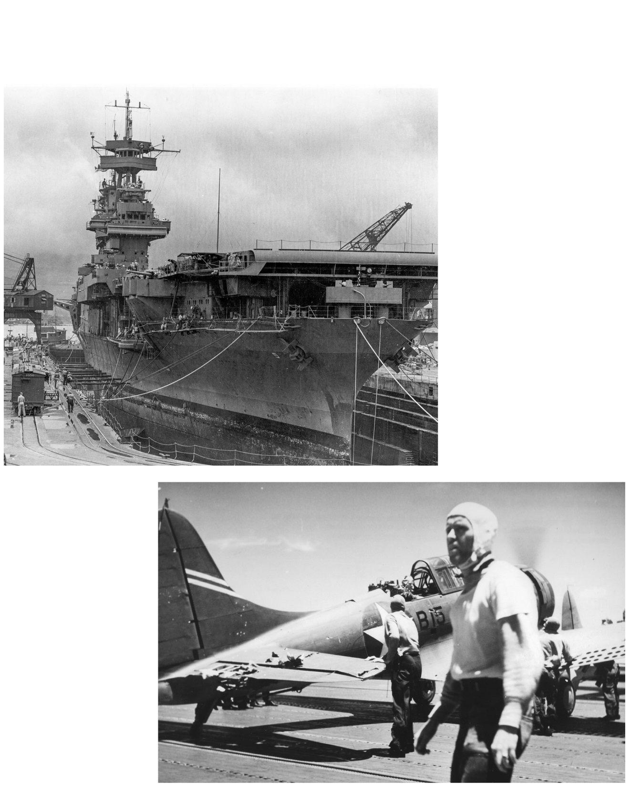
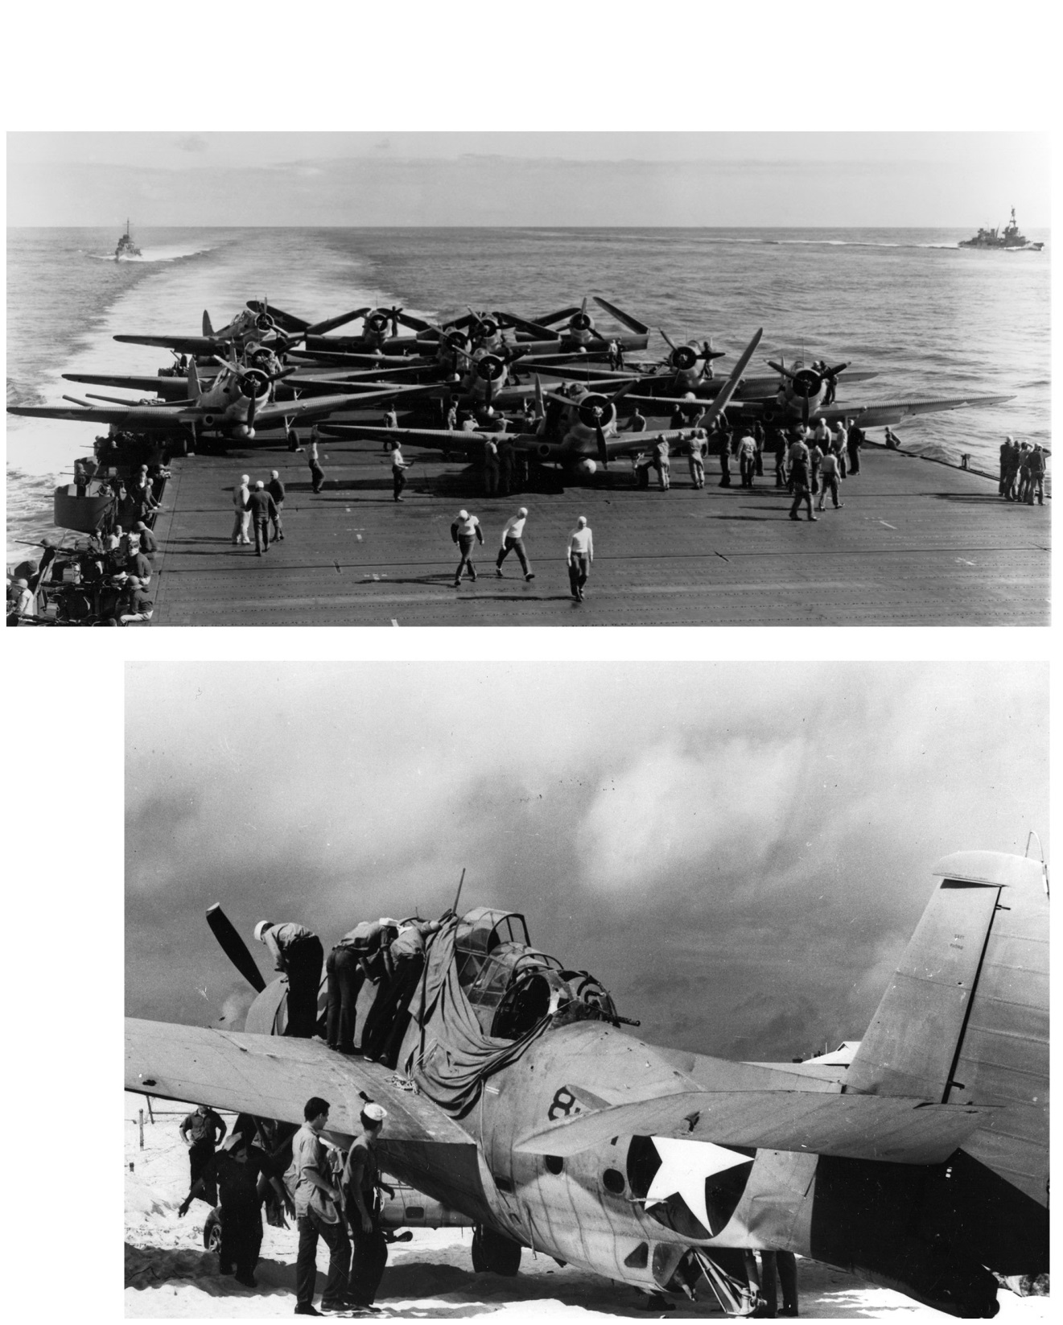

[Insert Title]

[Insert Text/Heading]
[Insert details]

[Insert Text/Heading]
[Insert details]

[Insert Text/Heading]
[Insert details]

[Insert Title]

[Insert Text/Heading]
[Insert details]

[Insert Text/Heading]
[Insert details]

[Insert Text/Heading]
[Insert details]

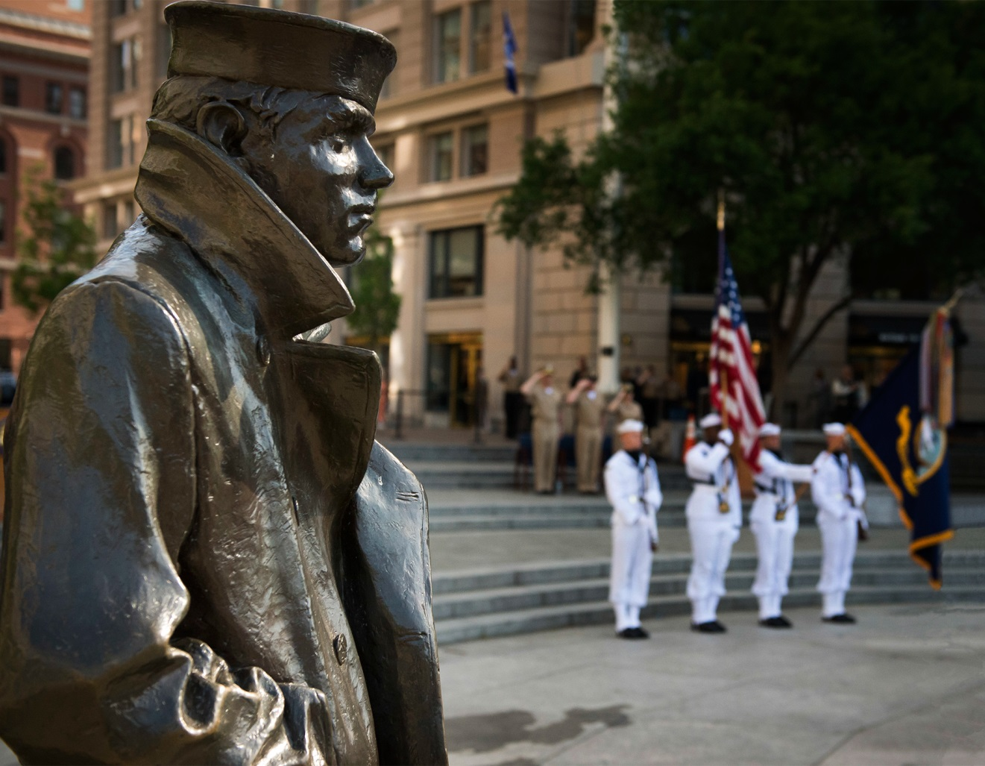

U.S. Navy at Midway
“Through the skill and devotion to duty of their armed forces of all branches in the Midway area our citizens can now rejoice that a momentous victory is in the making.
It was on a Sunday just six months ago that the Japanese made their peace-time attack on our fleet and army activities on Oahu. At that time they created heavy damage, it is true, but their act aroused the grim determination of our citizenry to avenge such treachery, and it raised, not lowered, the morale of our fighting men.
Pearl Harbor has now been partially avenged. Vengeance will not be complete until Japanese sea power has been reduced to impotence. We have made substantial progress in that direction. Perhaps we will be forgiven if we claim we are about midway to our objective!”
—Admiral Chester W. Nimitz, Commander-in-Chief, Pacific Fleet

