The Battle of Midway pop-up display graphics are provided to support commands with their commemoration efforts.

Note: Every effort has been made to provide instructions that allow for accurate and precise replication of the prepared layout. However, software settings and performance vary from user to user and may affect the appearance of the downloaded file.

Printing Considerations

The three PDF files are provided for users who would like to print a full-scale version of the three pop-up display graphics. Each pop-up display is sized at 33 inches wide by 86 inches tall, which includes an extra 8.25 inches of blank space at the bottom of each panel to allow the panel to roll up into the special hardware (see last paragraph in this section).

Due to the large format of these displays, it is highly recommended that commands who choose to print the pop-up display graphics outsource this print job to DLA or other vendor. To do so, you will need to save the PDF files to a disc and bring that disc to your designated printer. You will also need to follow your command’s procedures for submitting outsourced print jobs (See DLA Document Services section below).

**When submitting your print job, make a note to the printer that the finished document size of each pop-up display graphic will be 33 inches wide by 86 inches tall, with a top/left/right bleed of 0.25 inches and a bottom bleed of 1 inch. You must also let them know that an extra 8.25 inches of blank space has been added to the bottom of each panel to allow the panels to roll up into the hardware. If they do not need that extra space, the printer will have to crop each panel where they deem it necessary.**

Please note, the proper display of each pop-up graphic requires special hardware to which the banner can attach. Please coordinate with your chosen printer to ensure that the hardware is included with your order. The photo below is an example of a complete unit (of another design, not the Battle of Midway design. The Battle of Midway graphics will be assembled in a similar fashion):

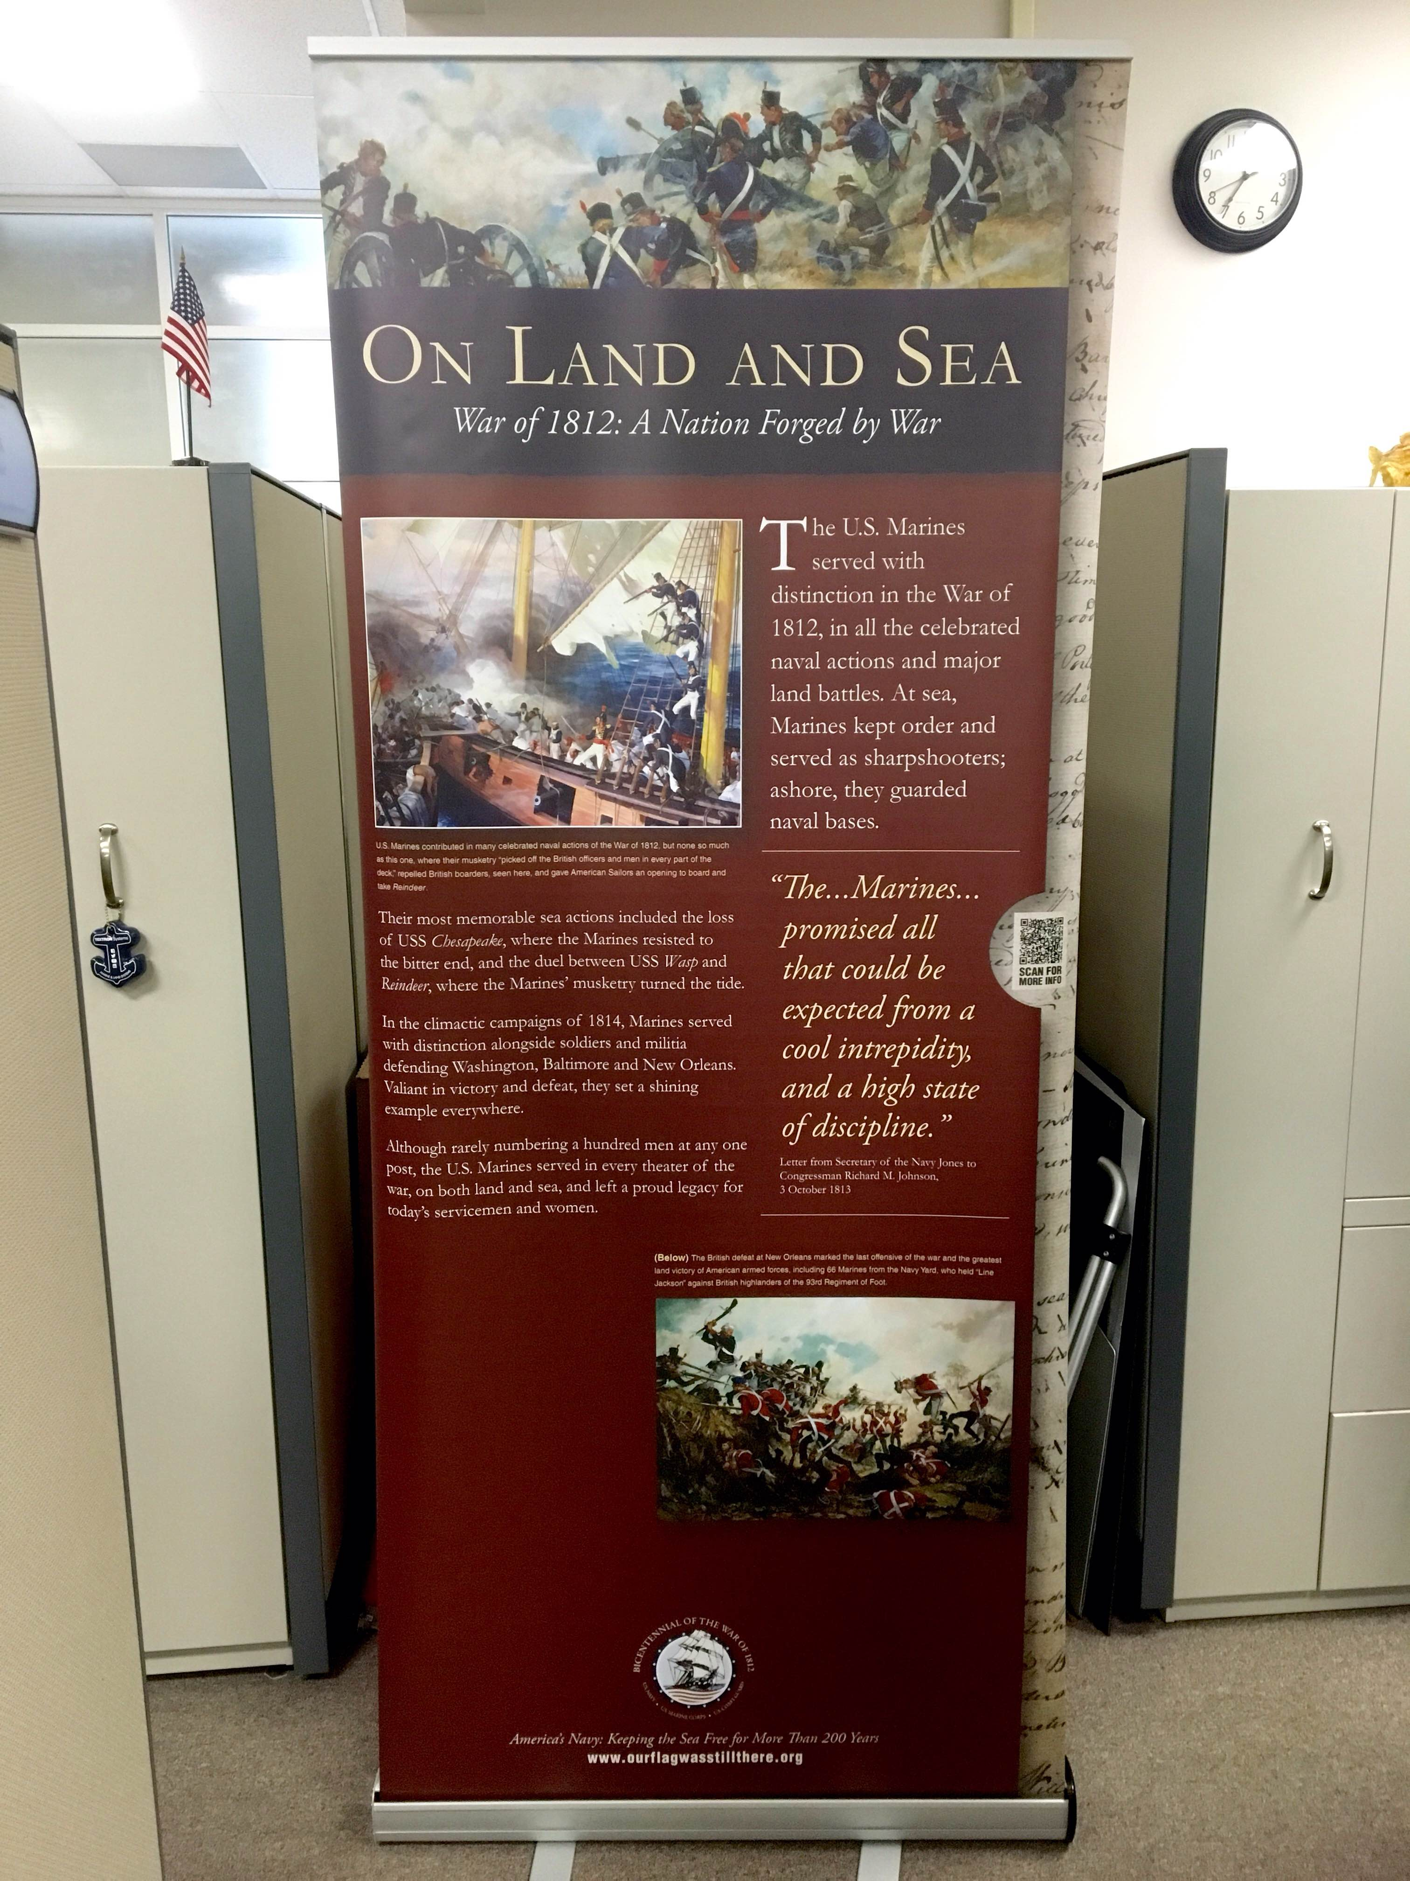

Printing Instructions

Plotter Printing
Full-size printing of the Battle of Midway pop-up display graphics in-house is certainly possible if your office has a large format plotter printer and a person with experience in using a plotter. However, please note that without the proper hardware to attach the graphics, displaying them will be somewhat difficult due to the large nature of these graphics.

Providing a step-by-step guide to printing this product on a plotter is not possible due to the variations that exist from plotter to plotter, but by using your plotter’s software you should be able to print the PDF files from a computer that is connected to the plotter. Keep in mind the dimensions of the graphic (33 inches wide by 86 inches tall) so that you can select the correct orientation of the document so that it fits the print width of your particular plotter.

DLA Document Services
Please follow your command’s procedure to submit your Battle of Midway pop-up display graphics print-ready files and DD282 form to DLA Document Services for professional printing.

