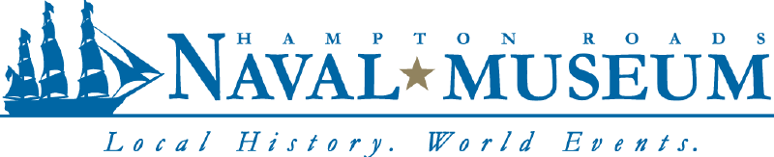

Exploring History with the Hampton Roads Naval Museum

Did you know? The Hampton Roads Naval Museum offers naval history and heritage programs, including CPO 365 tours of the museum and naval history talks at your command.
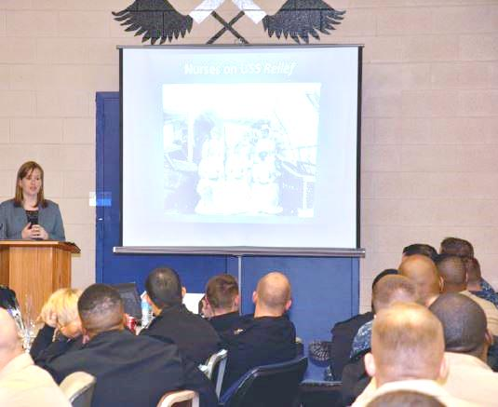

Topics for talks:

- The Battle of Midway
- A History of the Navy’s Birthday
- The History of Naval Aviation
- African Americans in the Navy
- Women in the Navy
- The Pearl Harbor Attack
- An overview of the museum
- Leyte Gulf
- USS Wisconsin’s history
- Battle of Hampton Roads
- The Navy’s role in Vietnam

Looking for a talk that isn’t on the list? Give us a call!

All tours and lectures are completely free of charge and we will come to you. Call (757) 322-2992 or email eddie.duckworth@navy.mil to book your program today.

