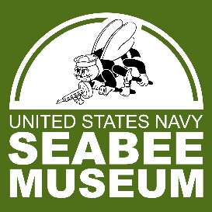
USNSM VISITATION POLICY
JULY 2023

Hours
Monday through Saturday 10am to 4pm
Tours and Events
The museum offers guided tours to groups of 10 people or more.
The museum facility is available for official Navy ceremonies and events for groups of 35 people or more.
No Food allowed in the museum, only water is allowed in the museum and must be in a water bottle or sealable container.
Contact NHHC-SeabeeMuseum@us.navy.mil to make a tour reservation or schedule an event.
Visitor Guidelines:
To help ensure physical distancing and a safe, comfortable experience, USNSM will be operating with the following visitor guidelines in place:
- In accordance with Navy guidance, mask wear for fully immunized personnel (two weeks beyond final dose) is no longer required indoors or outdoors at DoD facilities.
- Immunized visitors should continue to comply with Centers for Disease Control and prevention guidance regarding areas where masks should be worn.
- Please do not enter the museum if you feel sick or have a temperature over 100 degrees.
- Exhibits require one-way foot traffic flow.
- USNSM does not accept unsolicited on-site drop-off of historical material donations.

